GAGAN based Mobile-App for Geotagging of assets created with the financial support of CSB
Technical guidance & Procedure Manual
GPS aided Geo-augmented Navigation (GAGAN) based mobile app for field data collection for collecting data and hosting of the same in Sericulture Information Linkages & Knowledge System (SILKS) Web Portal. This mobile app will provide a platform for crowd sourcing and geo-tagging, where Field level officers will collect geo-tagged photographs of assets, fill the attributes and upload the assets into SILKS web portal. This app ensures to send the collected data to the SILKS server. After data posted from GAGAN based mobile app, user can visualize field data with all the attribute information on the interactive map dashboard. This dedicated dashboard contains: interactive visualization, navigation; map query based on filtering based approach and visualization of statistics via charting tools.
The following steps should be followed when you upload data collected with GAGAN based mobile app.

Step 1: Enable/on your mobile Bluetooth option () to pair with GAGAN Dongle/device.
Step 2: Search for GAGAN Dongle in Bluetooth Available devices.
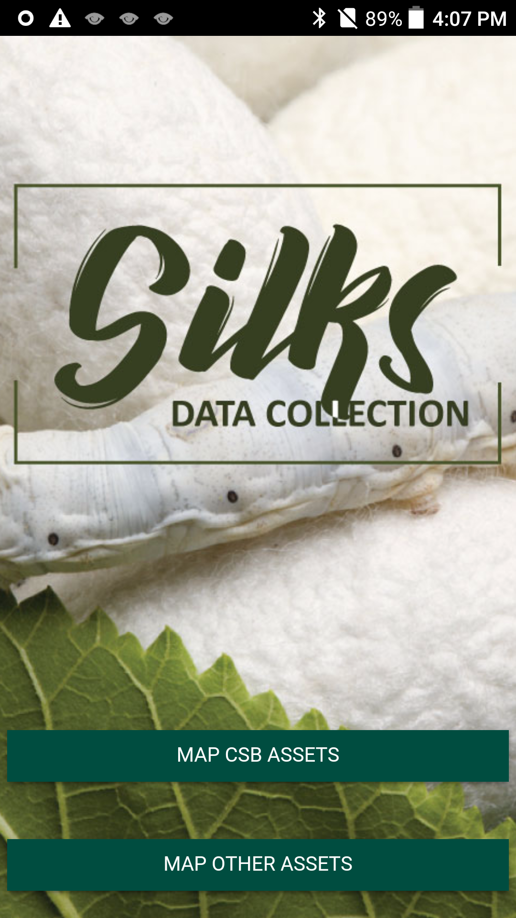
Step 3: Pair/Connect the GAGAN dongle device name “NAVSHAR”.
Step 4: Install GAGAN Based Mobile App: Open your android mobile phone and install mobile app from the dedicated link:

http://14.139.219.221:8080/apk/silks.apk

Map CSB Assets
Map Other Assets

Step 5: When you open the app after the successful installation from the mentioned link, there main tasks in this app are: (1) Map CSB Assets (2) Map Other Assets
Instructions:
(1) Map CSB Assets: This option dedicated to central sericulture board officers to geo-tagged assets of CSB.
The step by step procedure for using the app by the officers to geo-tagged assets of CSB is given below.

GAGAN based Mobile app process Flow chart for MAP CSB Assets
1. Chose MAP CSB assets option (screen 01: first option) then screen 02 will appear with dropdown menus like:
MAP CSB Assets

Select Technology with options: Pre-Cocoon and Post-Cocoon (screen 03).
With the Farms: option then “sectors” will appear on next menu like Mulberry, Tasar, Eri, Muga (screen 06), select one sector from the dropdown menu then next option will come with sector’s varieties (different verities are associated with each sectors), chose one variety (screen 07) according to your requirement you can chose other remaining sector options with different varieties.

User select Building/Infrastructure option from select option then “sectors” will appear on next menu like Mulberry, Tasar, Eri and Muga select one sector from the dropdown menu then next option will come with sector’s infrastructure like Adm.-Building, Labs, Trg.bld, R House, Grainage, Irrigation, C well, Others.

Select with Pre-Cocoon option: then second option will show: Select infrastructure with two dropdown menus: Farms and Building/Infrastructure (screen 05)
Select Post-Cocoon option from select Technology dropdown menus: (screen 03 first option)
Next only one option will appear: Building/Infrastructure then select infrastructure option with the dropdown values:
Adm.-Building,
Pilot plants,
Trg / demonstation.bld,
Testing unit,
Bore-well,
C well,
Others

GAGAN Dongle connection for get-location: After performing above mentioned steps next screen will appears with Describe information, where user can click a photo from the photo capture option and fill the necessary details like uploaded by, place of unit, year of estimation etc. (screen 08 and screen 09 after clicking photograph). Another option: Scan paired device option: this option connects with paired device “GAGAN dongle” with name NAVSHAR (screen 10 & 11), select NAVSHAR and connect with GAGAN dongle through connect to dongle option and click get location option (screen 12) for capturing remote location. After connection and get location now you are ready to send record to the silk server click submit button (screen 13) after submission record will be visualize on the map dashboard. (NOTE: without photograph and location information your record will not be uploaded on server for both cases).

GAGAN based Mobile app screen shots for MAP CSB Assets user operation

(Screen 01) (Screen 02) (Screen 03) (Screen 04) (Screen 05)

(Screen 06) (Screen 07) (Screen 08) (Screen 09) (Screen 10)

(Screen 11) (Screen 12) (Screen 13) (Screen 14)
(Above process should be followed for Post-Cocoon option -> Building/Infrastructure -> Infrastructure: [Adm.-Building, Pilot plants, Trg / demonstation.bld, testing unit, Bore-well, C well, others]) -> Submit.

(2) Map Others Assets: This option dedicated for plan geo-tagging to other assets.
Flow chart for MAP Others Assets
Map Others Assets

Select plan Geo-tagging with options: Plantation and Building / other Infrastructure (screen 02)

Building / other Infrastructure option: Next option will open “select sector:” Tasar (screen 03, only one sector mentioned in dropdown menu)
Plantation option: Next option will open “select sector:” Tasar (screen 03, only one sector mentioned in dropdown menu)

Select Tasar sector, next option will appear: Select Host Plant species: with the value: T. Arjuna and TAsan (screen 04)
Select Tasar sector, next option will appear: Select infrastructure: with the value:
BSPU
Grainage
Rearers’ Collective
Reelers’ Collective
Cocoon Bank
Yarn Bank

After performing all the steps for plan geo-tagging other assets, you need to perform GAGAN Dongle connection for get-location, same process that you have performed for Map CSB assets operation (please refer GAGAN connection procedure and get location), after connection and get-location click submit button for upload data to SILK server/portal.
GAGAN based Mobile app screen shots for MAP CSB Assets user operation

(Screen 01) (Screen 02) (Screen 03) (Screen 04) (Screen 05)
(Above process should be followed for Building / other Infrastructure option -> Tasar -> Tasar Sectors: [BSPU, Grainage, Rearers’ Collective, Reelers’ Collective, Cocoon Bank, Yarn Bank]) -> Submit.

